Exp No: 6
ARDUINO TO 16x2 LCD DISPLAY USING PROTEUS

AIM:
To write an Embedded C program to interface Arduino Uno and 16 x 2 LCD display using
Arduino Uno and Proteus

SOFTWARE REQUIRED:
• Proteus 8 software.
• Arduino IDE software

CIRCUIT DIAGRAM:
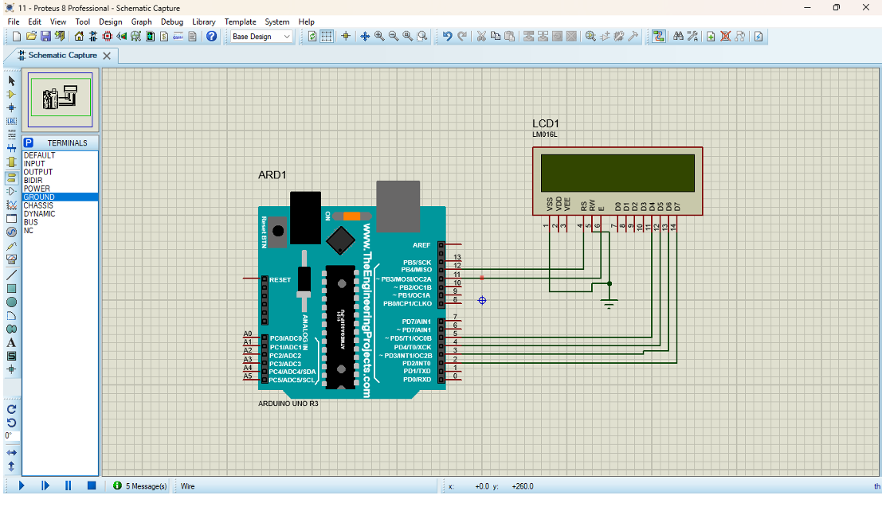
PROGRAM:
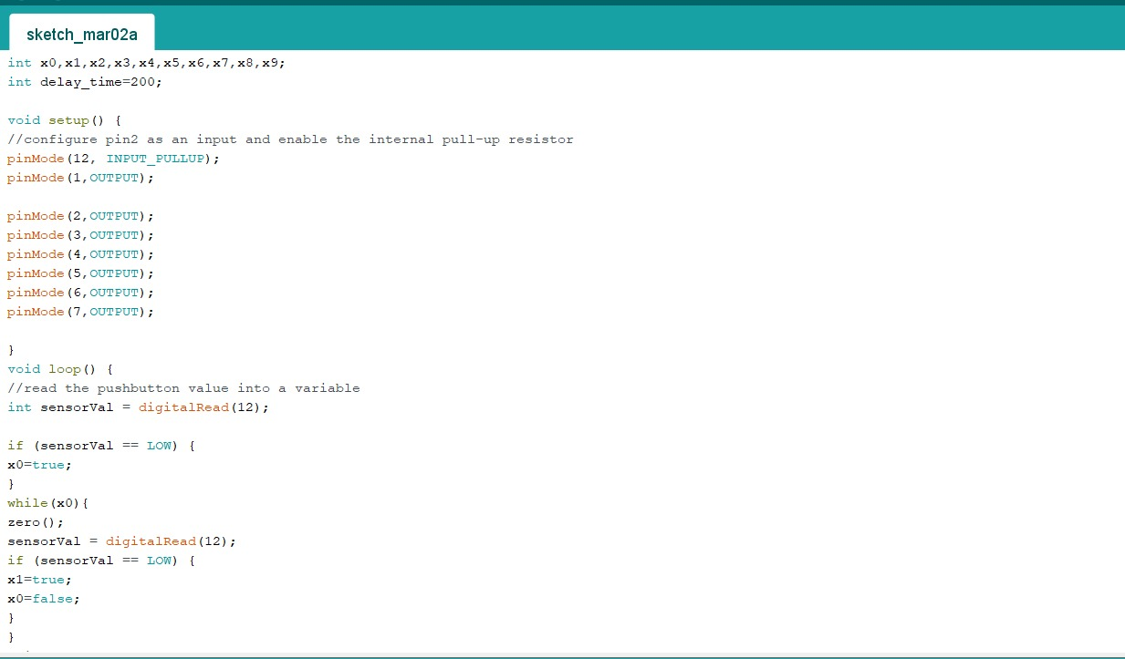
OUTPUT:
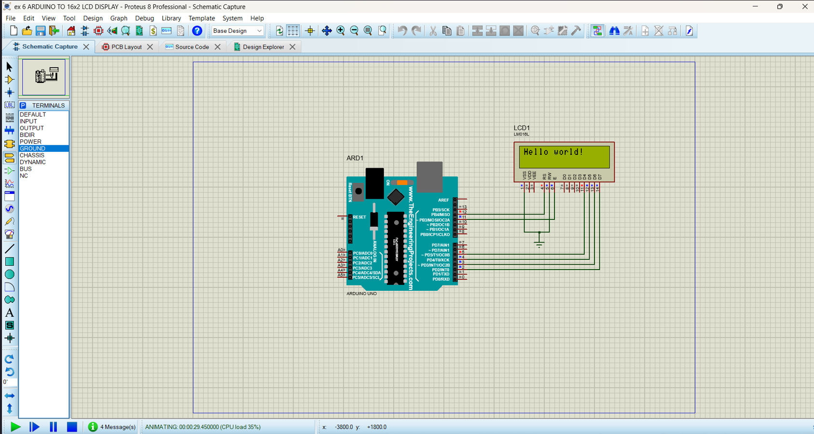
RESULT:
Thus the program has been successfully verified and executed.

